ENERGY AND MATTER IN ECOSYSTEMS

Ecosystems rely on the movement of energy from one part to another. Energy is the ability
to do work.

• Energy may be free (e.g. Heat flowing through the air.)
• Energy is locked into the bonds of matter (e.g. The energy in glucose).

Matter is recycled within ecosystems. It is neither created nor destroyed.

Energy is transferred through ecosystems. When energy is ‘used’, it is actually converted into other forms.

Flow Of Energy

The first source of energy in most ecosystems is solar energy via photosynthesis.

Animals obtain their energy from plants and other animals (which have eaten plants), but not
all the energy is passed on. In any food chain, only about 10% of energy is passes from one organism to another.

i.e. Plants use some of the energy themselves, and some of the energy is lost to the
atmosphere as heat.

Energy in an ecosystem flows in only one direction.

Energy is not recycled within biological systems (although it is conserved in the universe). Living systems continuously take in more energy from the Sun. The energy moves through ecosystems (converted into different forms for work), some of it is lost as heat.
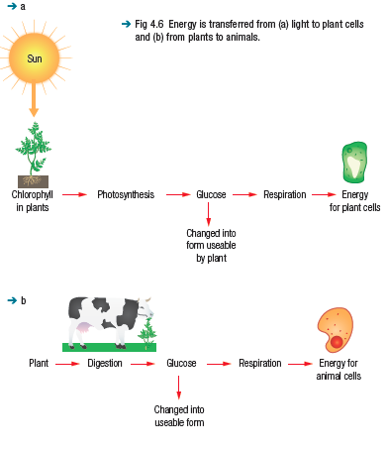
ENERGY FOR WORK

When we need energy, we often head straight for sugary foods. Although sugars contain energy
locked in the bonds of their molecules, this energy cannot be used directly by organisms. They
must convert it into other forms.

Many energy transformations keep a living organism alive, functioning and carrying out metabolic
processes (chemical reactions that keep cells working).

We can describe these processes as the work of living organisms. Some of the types of ‘work’ performed by living organisms are shown in Table 4.1.

